**Survey analysis**

As part of our development of the **Bookme** interface, we conducted a survey with a sample of around 20 participants to gain valuable insights into the app’s user experience and to compare it with other ticket booking platforms. The survey aimed to explore key elements of an acceptable interface focusing on aspects such as ease of use, visual design, navigability, and overall user satisfaction. The following were the results of our analysis that we considered important factors.

**Highest education level**

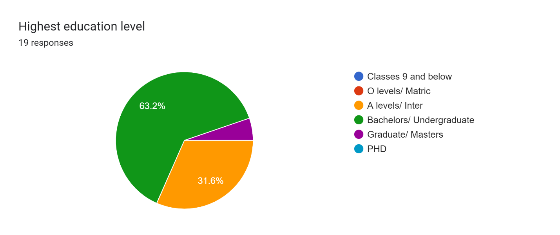

This was a way to gauge whether or not our customer base is well equipped with knowledge of how the world works, i.e. a student from lower classes could struggle understanding more complex interfaces and advanced features whereas the opposite would prefer simpler designs. A background understanding as such is necessary to guide us in our design process. Judging from these statistics, we can assume that our audience who is at the very least doing bachelors or a-levels would have a smaller learning curve with more complex features if we were to implement them.

**Industry of occupation**

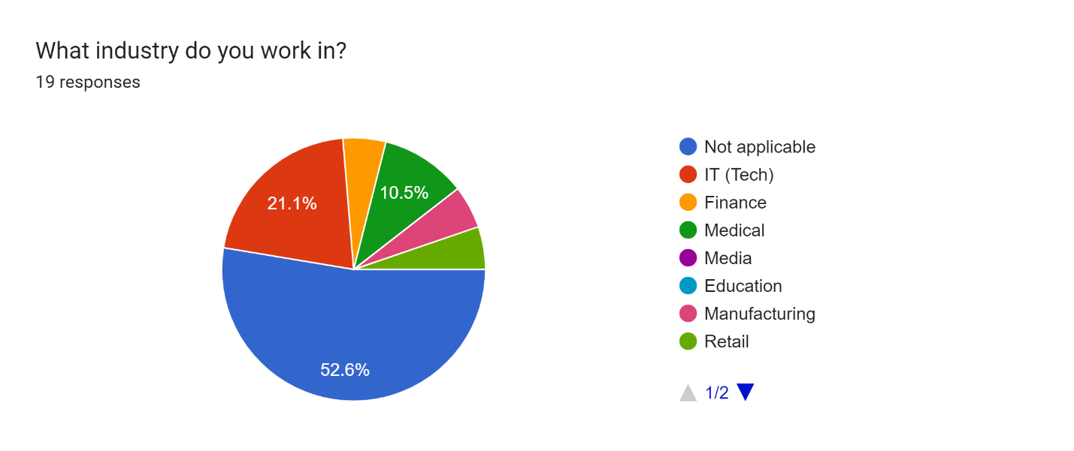

A majority in not applicable was due to the majority of our sample size being students, however by basing off which industries they are linked to we can cater to their needs accordingly i.e. individuals from the IT industry would be comfortable with more tech-oriented features, someone in media would appreciate the aesthetics and layout of your website a lot more, medical backgrounds would mean comparatively less tech savvy people and thus simpler features to get their tasks done. Finance background users would be very critical of our transaction processes and thus would also wish for several payment modes.

**Familiarity with technology**

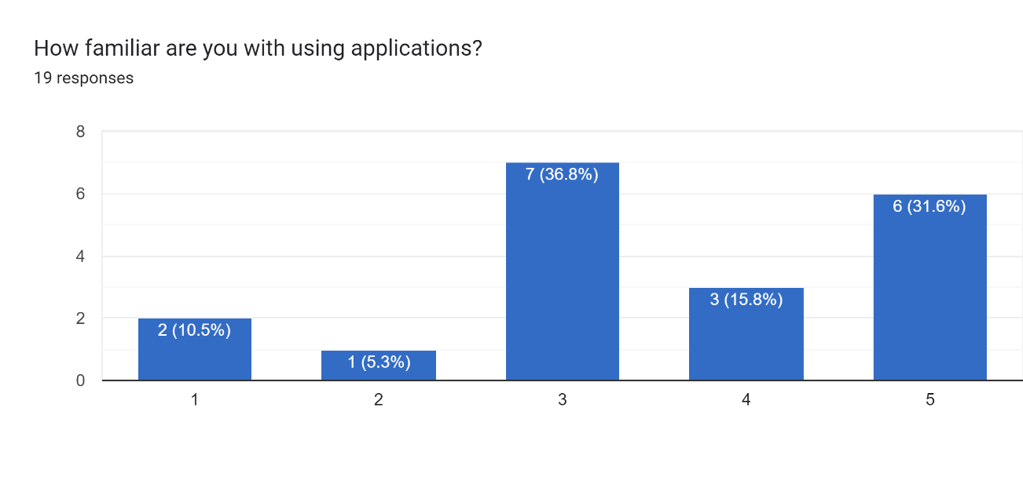

This is self explanatory but the more our customer base is comfortable with applications and technology, the lesser we have to worry about pinpointing the use of every single button and action.

**Disabilities**

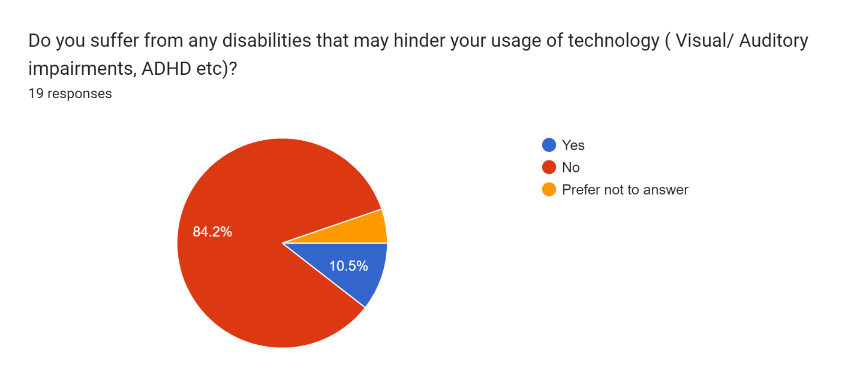

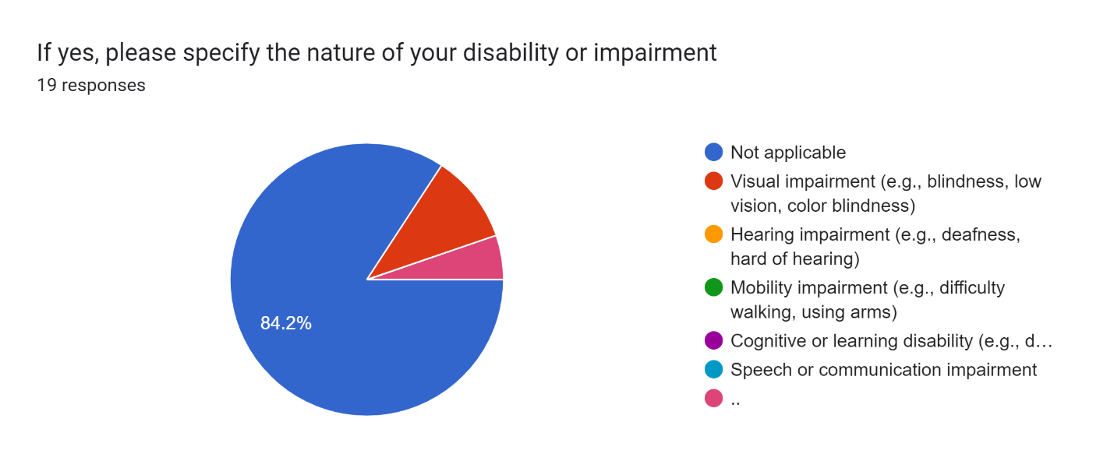

Forms response chart. Question title: What types of solutions or accommodations do you prefer to help with your disability or impairment? (Choose all that apply)  
. Number of responses: 19 responses.

While potentially in the minority, individuals with disabilities are just as valuable as those without and so understanding them accordingly and catering to their needs is imperative. By getting a deeper insight to what exactly the majority of disabilities are, we can leverage our focus to target the more dominant issues, i.e. visual impairment is relatively common these days thus being the most dominant feature here. By then further analyzing what solutions a customer would prefer, to aid with their impairments in terms of accessibility features, we can narrow down the most important features to implement in our design for example in our survey, cognitive support and magnification software seem to be preferred by most users.

**Ticket booking platforms**

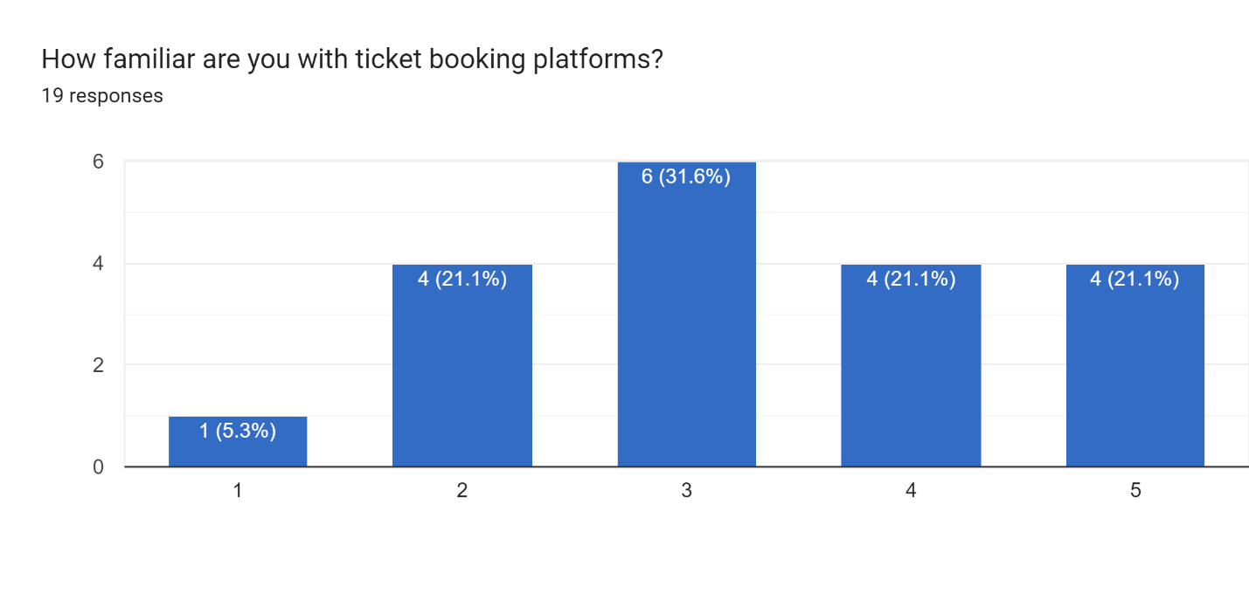

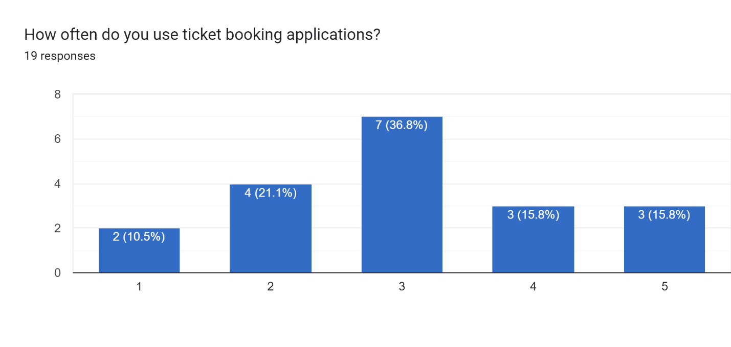

We then took to our main problem i.e. ticket booking platforms, by getting a brief idea firstly of whether or not our sampled individuals have awareness of these apps. After awareness comes usage which is a very important metric as we can use this to see how much a user would access these apps, ranging from 1 (barely) to 5 (all the time). This allows us to understand whether or not our sampled individuals are frequent users as well. Seeing as a majority of them use ticket booking apps at least sometimes alludes to the fact that the insights from them could be of use.

**Competitor analysis**

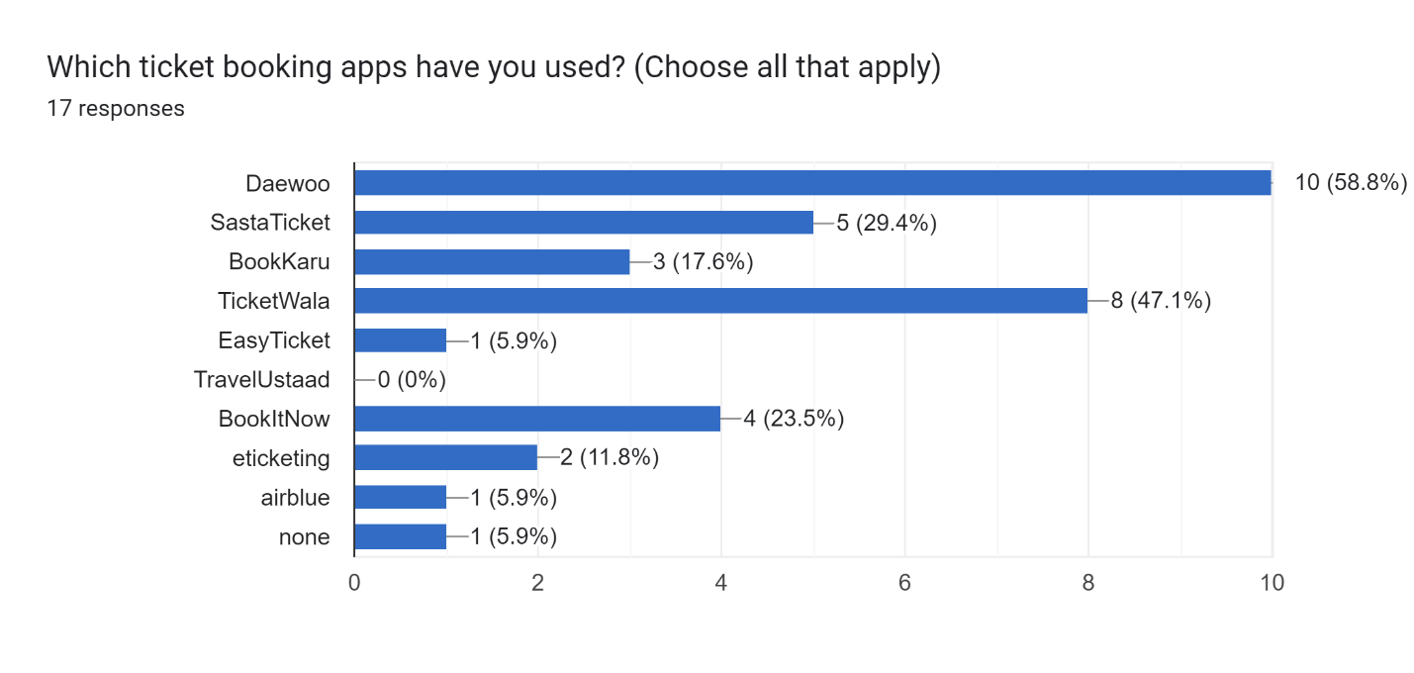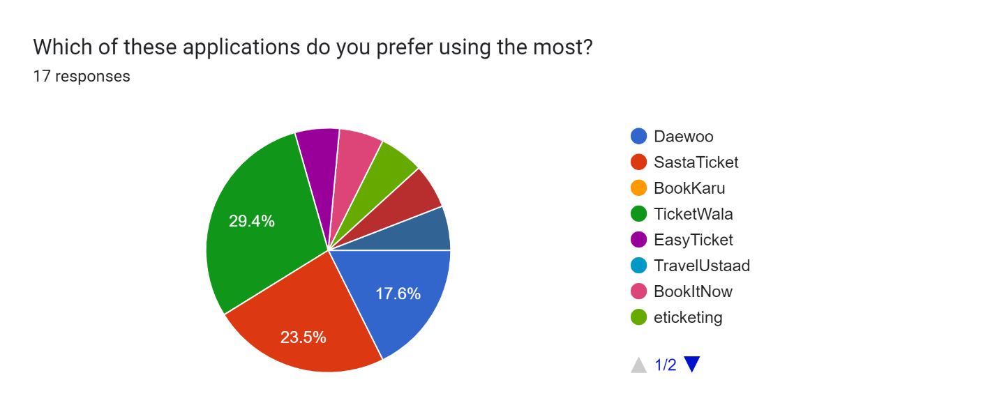

This question served to understand who our biggest competitors were, in terms of interface design this is crucial as we can then see what these companies do better and worse than us to find our strengths and weaknesses accordingly and improve based on those factors. Among these Daewoo obviously has something over the rest in terms of a larger userbase however a deeper dive shows that the majority of users prefer Ticketwala and Sastaticket over it. This could guide our portress in terms of seeing what attracts customers to Daewoo and what keeps them engaged and loyal within Ticketwala and Sastaticket.

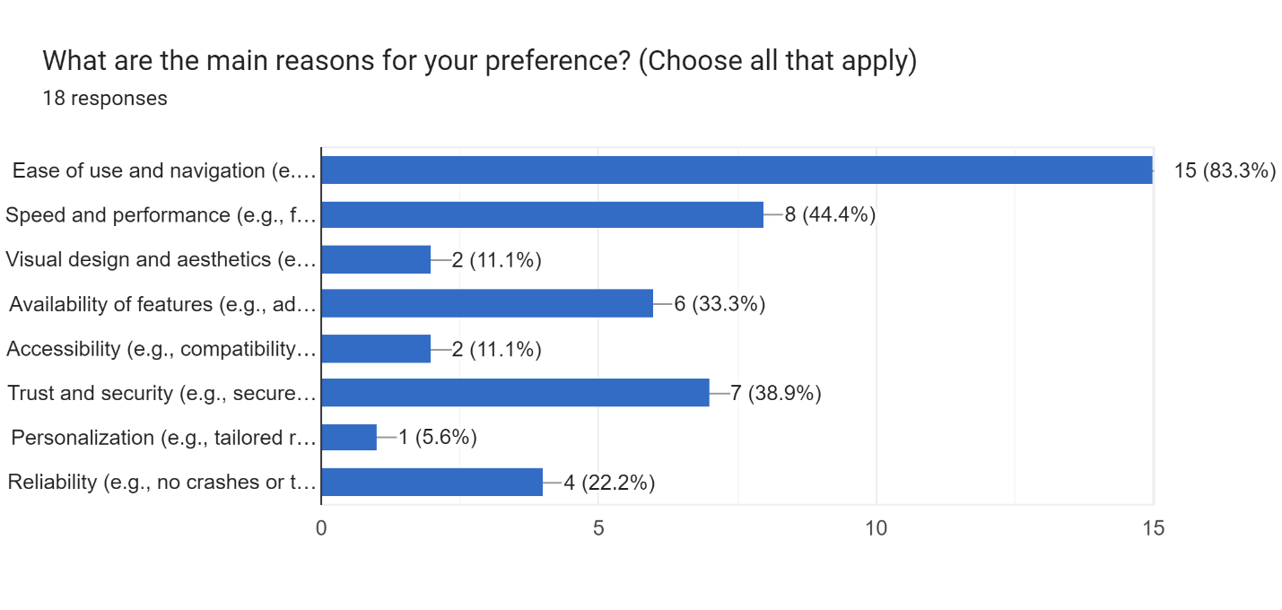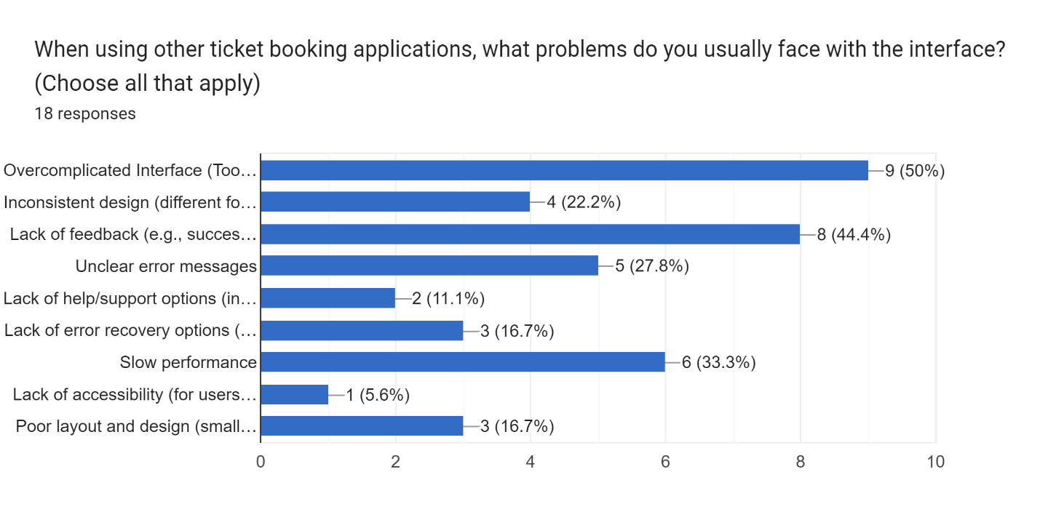

We then checked what exactly about these apps held customers and the majority vote was for ease of use and navigation meaning this is something we definitely have to focus on when designing our interface to make sure audience retention is maintained. We also then look among the lesser used and preferred apps to find reasons users may deter from them. The major ones being overcomplicated interfaces, lack of feedback and slow performance, all three are integral in determining the quality of an interface for user experience needing heavy emphasis.

**User insight**

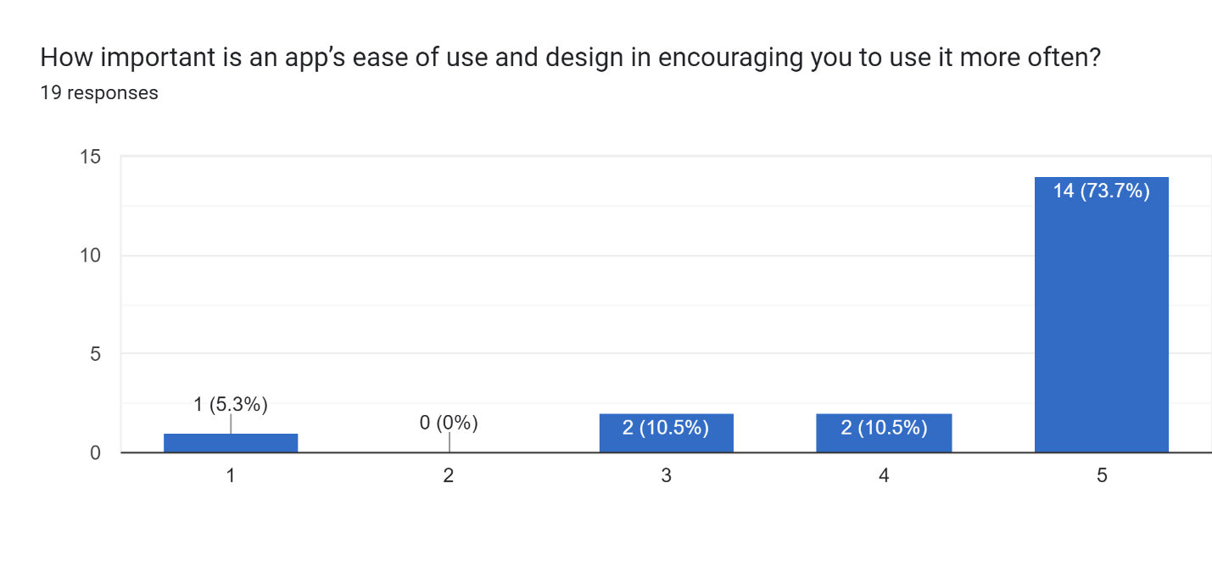

This was a more generalized question to see whether or not users care about ease of use and design and how much it affects their view of an app and thus future use, with the majority opting for maximum importance for these two factors further highlighting the need for ensured quality when it comes to user interaction with the software.

**Bookme based questions**

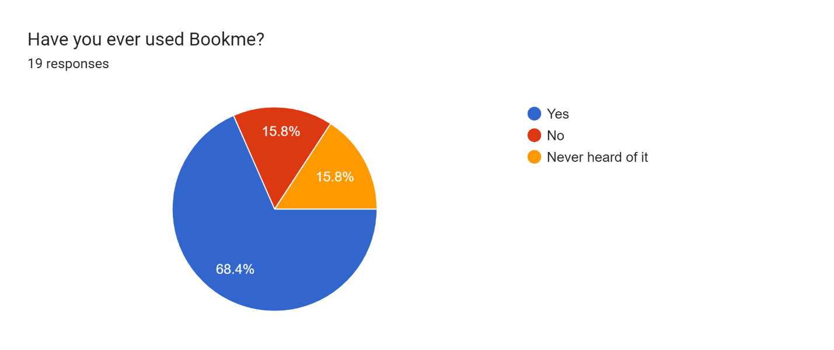

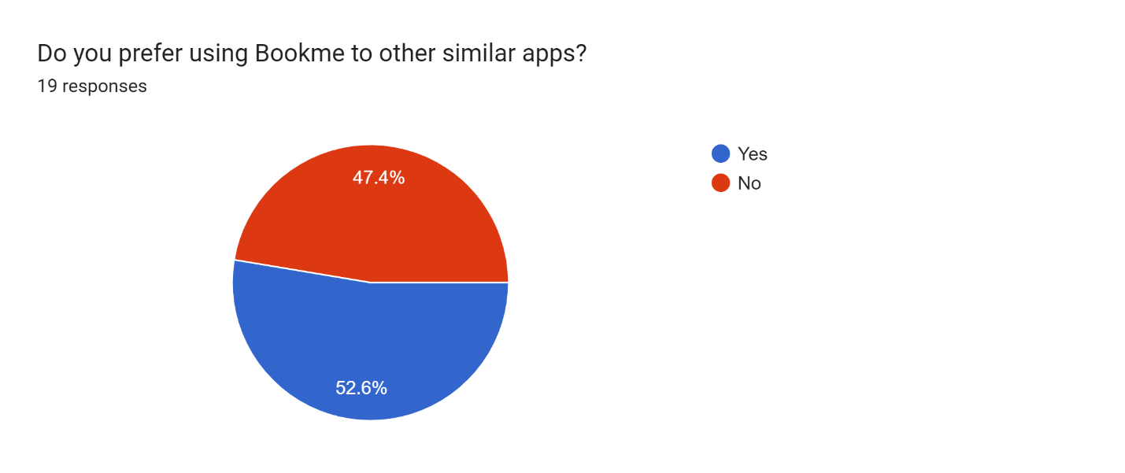

The first two questions are more generalized firstly gauging how many of our sampled users have actually used bookme, luckily a majority. The next part being whether they prefer bookme to the previous similar apps and this is almost even, meaning there’s definitely room for improvement for bookme to increase their userbase.

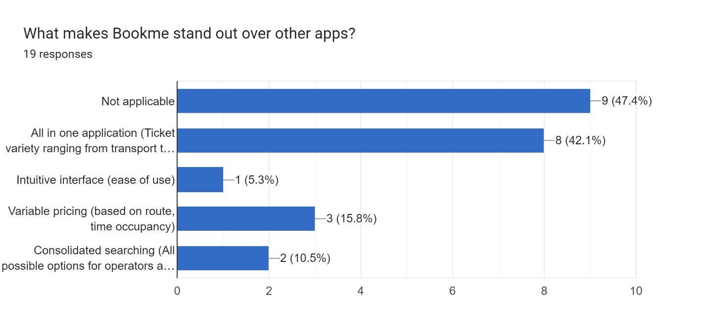

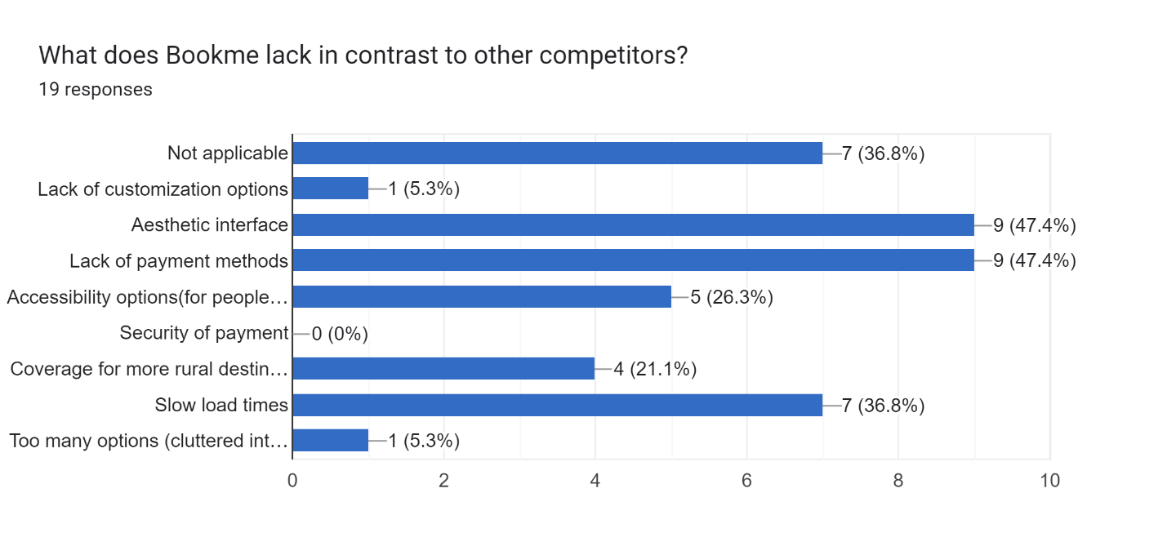

We then take a look at the strengths and weaknesses of bookme, in terms of positives it’s clear that bookme’s biggest attraction is its wide variety of ticket options ranging from travel to events to movies etc, followed by their variable pricing plans. The factors holding bookme back on the other hand include, an aesthetic interface for starters, this is a clear indication that bookme’s focus on simplistic and an easy-to-use interface overshadows the need for aesthetics, the app is unappealing to look at turning customers away. Furthermore, a lack of payment options is another major factor as well as slow load times.

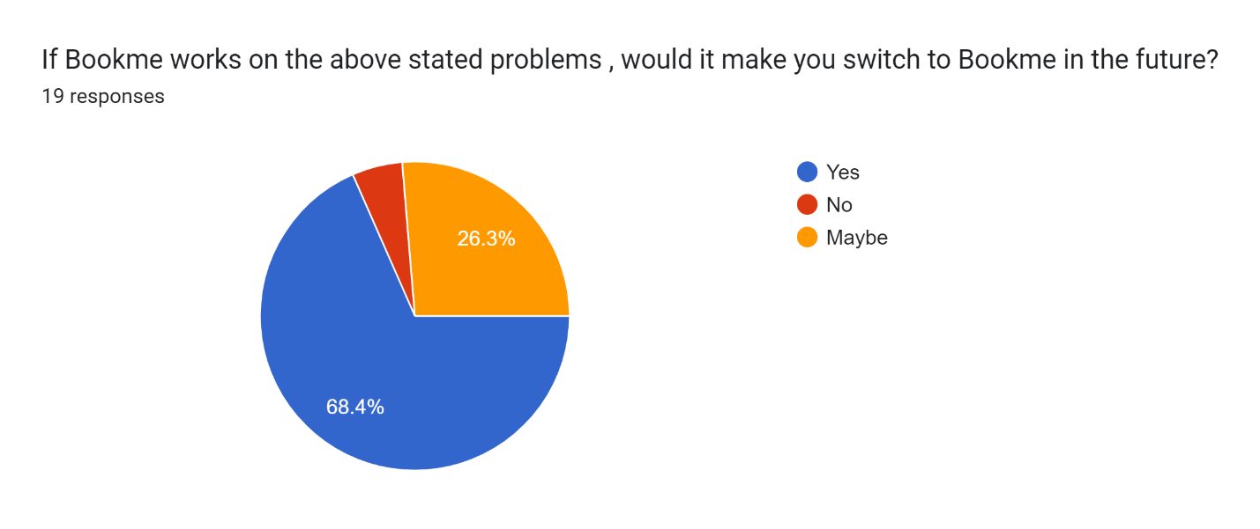

This question further confirms that the half of the sampled users that preferred other apps would end up switching over to bookme if these strentghs were polished and the weaknesses were dealt with. These incentives would be enough to at the very least motivate users to give bookme another chance.

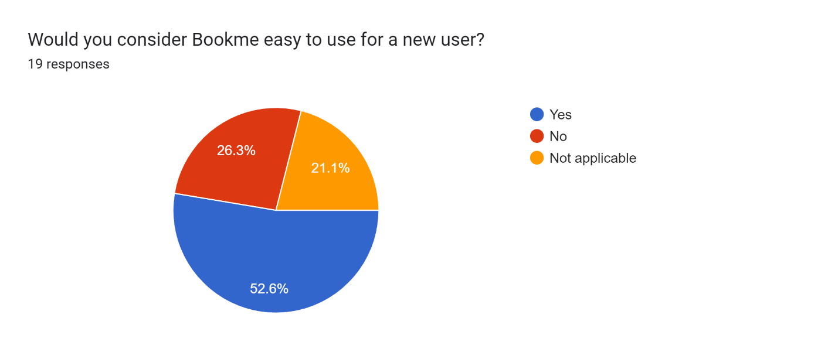

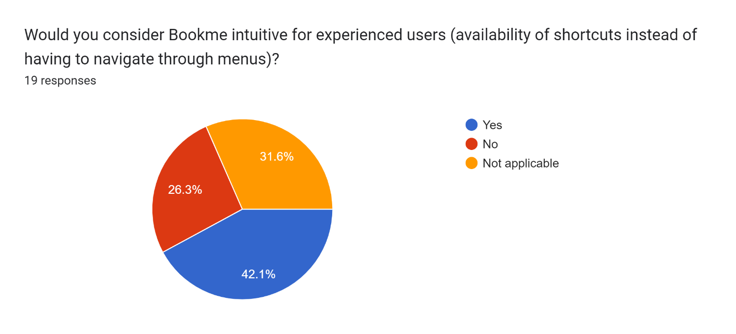

These are benchmark questions testing the learnability principle and also the use of shortcuts for bookme. We can see that our survey states a majority of users find bookme easy to use for a beginner which means it has high learnability, alternatively shortcuts although in the majority are not as dominant stating that there is a need for more shortcuts to improve user flow.

**User suggestions**

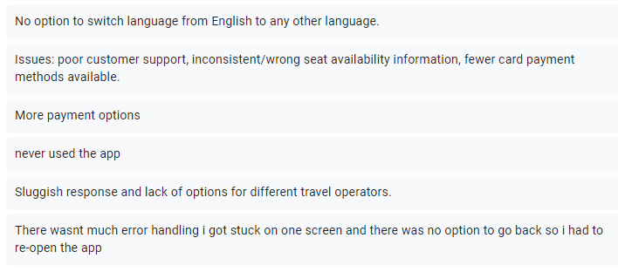

These suggestions help a great deal as they lean into personalized problems users may face, for starters a lack of languages, being dominant in Pakistan and offering rural options, the app needs an Urdu language version as well, as a majority of the populus is not well versed in English.

The second suggestion states that the customer support is lacking which Bookme needs to step up on, it also mentions misleading seat availability information, this needs to be handled abruptly as this could make users feel the app is faulty and thus not trust it.

A lack of payment options, this was highlighted before as well as unfortunately bookme seems to only support HBL cards, this is highly inconvenient for several users who own accounts connected to other banks.

Slow response times have to be dealt with as customers could be in a hurry to book tickets, i.e. limited time events and the delays in processing could mean they lose out on the tickets which is a major inconvenience for the customer.

An increase in travel operators is also mandated as many customers feel the current options don’t suit them well.

Error handling is something that should not be taken lightly, the user’s complain of facing an error is already of concern but to also have no solutions or options to back out forcing a restart is unacceptable, this leads to a misconception of the app being broken just losing customers.